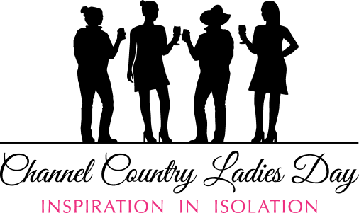
2025 Channel Country Ladies Day Scholarship Program
Application Guidelines in conjunction with

Opening date: 24 October 2025 Closing date: 16 December 2025
Website: http://channelcountryladiesday.com.au/ On Facebook and Instagram
Introduction
The Channel Country Ladies Day Scholarship Program 2025/26 is funded through The Channel Country Ladies Day Committee, thanks to the generous support of our scholarship partner, Santos.
Each scholarship is valued at $1500.00 and includes:
- Registration and tented accommodation for the 2026 Channel Country Ladies Day weekend from 16th – 18th October to be hosted within Quilpie Shire; including all catering and most activities over the weekend.
- Mentoring in one of three streams, including Arts, Health & Well-being or Personal & Business Development.
- Scholarship recipients will have the opportunity to choose their own path within the streams. This may include course or workshop expenses for approved online education opportunities or a contribution towards approved face to face course fees.
- 10 Scholarships are available.

Applications for our scholarships are open to all women who reside within the Channel Country
region whether you live in a small town or on a large pastoral station. You may self-nominate or be nominated by a friend or colleague. The Scholarships are for women who may have suffered adversity or may just need something like CCLD to give them a boost. Each scholarship will be awarded based on assessment against selection criteria detailed in Section 5 of these Guidelines.

Applying for the Scholarship
The Application Form is available online at http://channelcountryladiesday.com.au/ from 24 October 2025. Please submit your completed application by 5pm on 16 December 2025.
Late applications will not be accepted.
To apply:
- save this Application Form to your computer.
- complete all the questions and save your completed Application Form.
- email your completed Application Form to scholarships@channelcountryladiesday.com.au

Privacy
Any information provided to The Channel Country Ladies Day Committee, by a nominee about their nominated woman/women for The Channel Country Ladies Day Scholarships 2025/26 will be handled in accordance with the National Privacy Principles of the Privacy Act 2014.

Eligibility
To be eligible for the Channel Country Ladies Day Scholarships 2025/26 an applicant must be:
- a resident from the Channel Country Region, as per below map.
- The scholarships will be prioritised for those who would benefit from taking time out from their day-to-day life. Our scholarships are for women who may have suffered adversity or may just need something like CCLD to give them a boost.

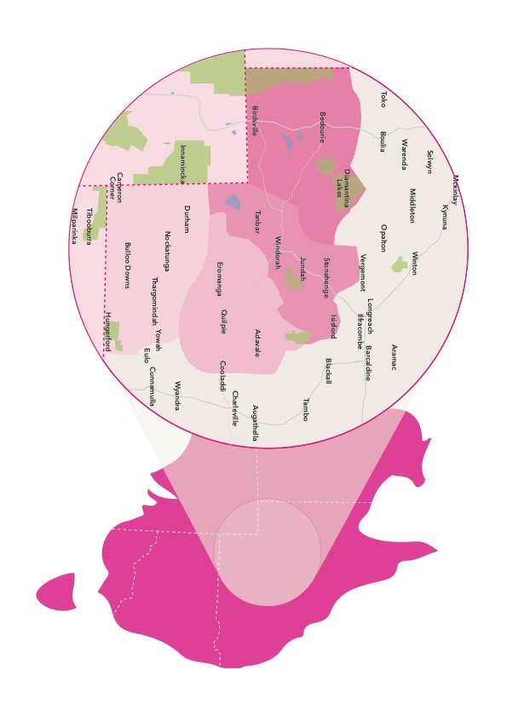
Selection criteria
The successful applicants will be selected based on:
- geographical/social isolation
- adversity they may have experienced
- financial barriers
- potential benefits for the individual and their broader community resulting from them attending the CCLD weekend. e.g. updating their knowledge and skills, improving health and well-being transfer/extending through community involvement.

Assessment and selection of the successful applicant
All applications submitted by the closing date will be considered according to the eligibility and selection criteria. A short list of applications will then be collated for consideration by the Advisory Committee. Should an applicant who has been offered a scholarship decline this offer or have the scholarship offer withdrawn, the scholarship may be offered to another eligible applicant. All applicants and nominators will be notified by email of the outcome of their application.

Advisory Committee
The Advisory Committee will comprise of nominees from The Channel Country Ladies Day Committee, including the President and the Scholarship Program Lead plus one nominated representative from Santos. The Channel Country Ladies Day Committee will make the final decision on awarding the Scholarships.

Withdrawal of a Scholarship
If the scholarship holder cannot attend the CCLD weekend, the Channel Country Ladies Day Committee will award that scholarship to a nominee from the shortlist of eligible nominations. The scholarship holder should inform the Scholarship Program Leads as soon as possible.

Contact Details - Scholarship Team
Email: scholarships@channelcountryladiesday.com.au
Contacts: Maree Morton - 0438 555 249 / Tracy Sargent - 0476 273 940

