With thanks to Scholarship Partner Santos for their ongoing support.

2021 Channel Country Ladies Day Scholarship
Application Guidelines

Opening date: 27 May 2021
Closing date: 30 June 2021
Email address: scholarships@channelcountryladiesday.com.au
Website: http://channelcountryladiesday.com.au/

Introduction
The Channel Country Ladies Day Scholarship Program 2021 is funded through The Channel Country Ladies Day Committee, thanks to the generous support of scholarship partner Santos.
Each scholarship is valued at $1000 and includes:
- Registration and tented accommodation* for the 2021 Channel Country Ladies Day weekend from 15th – 17th October 2019 at Quilpie; including all catering and most activities over the weekend.
- Mentoring in one of three streams, including mentoring and/or workshops leading up to CCLD or after depending on stream chosen

Scholarship recipients will have the choice between one of the three streams that form the basis of the CCLD weekend: Arts, with Quilpie artist Lyn Barnes; Health & Wellbeing, Pathways to Resilience; or Personal & Business Development, with Bec Fing, House Paddock Training and Consulting.
We have 10 scholarships available.
Applications for scholarships are open to all women who reside within the Channel Country
Region, whether you live in a small town or on a large pastoral station. The Scholarships are available to women who may have suffered adversity, or may just need something like CCLD to give them a boost. Successful applicants will be awarded based on assessment against selection criteria detailed in Section 5 of these Guidelines.

* Where the successful applicant does not require tented accommodation at CCLD, the equivalent value will be distributed to the applicant at registration for use on the weekend.

Applying for the Scholarship

The Application Form is available online at http://channelcountryladiesday.com.au/
The Application form will be available from 27 May 2021.
Applications must be submitted by 5pm on 30 June 2021.
Late applications will not be accepted.
To apply:
- Save this Application Form to your computer;
- Complete all the questions;
- Save your completed Application Form;
- Email your completed Application Form to scholarships@channelcountryladiesday.com.au

Privacy
Any information provided to The Channel Country Ladies Day Committee, by a nominee about their nominated women/women’s for The Channel Country Ladies Day Scholarships 2021 will be dealt with in accordance with the National Privacy Principles of the Privacy Act 2014.

Eligibility
To be eligible for the Channel Country Ladies Day Scholarships 2021 an applicant must:
- Be a resident from the Channel Country Region region, as per below map.
- The scholarships will be prioritised for those that would benefit from taking time out from their day-to-day life. They are for women who may have suffered adversity, or may just need something like CCLD to give them a boost.
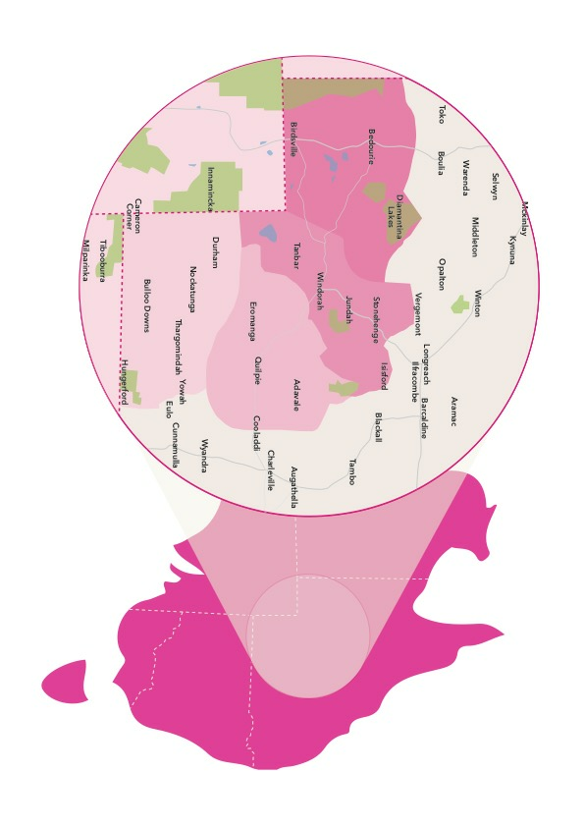
Selection criteria
The successful applicants will be selected based on:
- Geographical/social isolation
- Adversity they may have experienced
- Financial barriers
- Potential benefits for the individual and their broader community as a result of them attending the CCLD weekend. eg. updating their knowledge and skills, improving health and wellbeing transfer/extending through community involvement.

Assessment and selection of the successful applicant
All applications submitted by the closing date will be considered according to the eligibility and selection criteria. A short list of applications will then be produced for consideration by the Advisory Committee. As part of this consideration, the Advisory Committee may seek additional information from selected applicants. The Advisory Committee will make recommendation(s) to the Channel Country Ladies Day Committee, who will make the final decision on the awarding of the scholarship/s to the successful applicant/s.
Should an applicant who is offered a scholarship decline this offer or have the scholarship offer withdrawn, the scholarship may be offered to another eligible applicant.
All applicants and nominators will be notified by email of the outcome of their application.

Advisory Committee
The Advisory Committee will comprise of nominees from The Channel Country Ladies Day Committee, including the President and the Scholarship Program Lead plus one nominated representative from Santos.
The Channel Country Ladies Day Committee who will make the final decision on the awarding of the Scholarships.
Withdrawal of a Scholarship
If the scholarship holder cannot attend the CCLD weekend, the Channel Country Ladies Day Committee holds the right to provide the Scholarship to a nominee from the short list of eligible nominations. The scholarship holder should inform the Scholarship Program Lead as soon as possible.

Contact Details - Scholarship Program Lead
Contact: Tahna Jackson
Email: scholarships@channelcountryladiesday.com.au
Phone: 0409 357 211
Web: www.channelcountryladiesday.com.au

